H.T No
Regulations:
A17

Sreenidhi Institute of Science and Technology
(An Autonomous Institution)
Code No: 6B514 Date: 23-Jan-2023 (FN)

B.Tech III-Year I- Semester External Examination, January-2023 (Supplementary)
KINEMATICS OF MACHINERY (ME)

Time: 3 Hours Max.Marks:75
Note: a) No additional answer sheets will be provided.
b) All sub-parts of a question must be answered at one place only, otherwise it will not be valued.
c) Missing data can be assumed suitably.

Bloom's Cognitive Levels of Learning (BCLL)

Remember | L1 | Apply | L3 | Evaluate | L5
Understand | L2 | Analyze | L4 | Create | L6

Part - A Max.Marks:25

Answer all QUESTIONS.
 |  | BCLL | CO(s) | Marks
1 | Classify the kinematic pairs. Draw any two pairs. | L1 | CO1 | [2M]
2 | Locate all the instantaneous centers of a four bar mechanism. | L1 | CO2 | [2M]
3 | Distinguish between Davi’s and Ackermann’s steering mechanism. | L3 | CO3 | [2M]
4 | Define Cam profile, Pitch point and Lift. | L1 | CO4 | [2M]
5 | Compare length of path of contact and length of arc of contact. | L3 | CO5 | [2M]
6 | Differentiate between initial and centrifugal tensions in a belt. | L2 | CO6 | [3M]
7 | Define the inversion of a mechanism. | L1 | CO1 | [3M]
8 | Classify straight line motion mechanisms. | L1 | CO3 | [3M]
9 | State the law of gearing. | L1 | CO5 | [3M]
10 | Mention the different types of gear trains. | L1 | CO5 | [3M]

Part – B Max.Marks:50
ANSWER ANY FIVE QUESTIONS. EACH QUESTION CARRIES 10 MARKS.

 |  |  | BCLL | CO(s) | Marks
11. | a) | Explain the Kutzbach’s criterion for degrees of freedom of plane mechanism. | L2 | CO1 | [5M]
 | b) | Find the degrees of freedom for following two mechanisms.  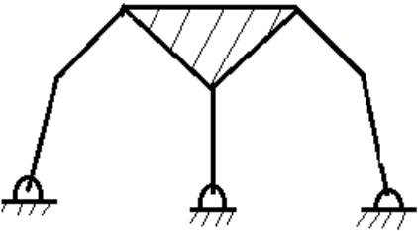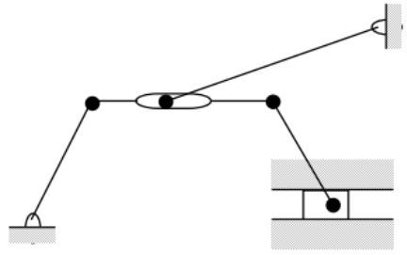 | L5 | CO1 | [5M]
12. | a) | Discuss the three types of instantaneous centers for a mechanism. | L3 | CO2 | [5M]
 | b) | The crank of an engine 200 mm long and connecting rod length to crank radius is 4. The has turned through 45˚ from inner dead center position. The instantaneous speed of rotation of the crank is 240r.p.m. clockwise and it is increasing at the rate of 100 rad/s². Determine:  i). acceleration of the mid –point of connecting rod,  ii). angular acceleration of connecting rod, and  iii). acceleration of slider. | L5 | CO2 | [5M]
13. |  | A Hooke’s joint connects two shafts which are having 160˚ as the included angle. The driving shaft rotates uniformly at 1500 r.p.m. Find the maximum angular acceleration of the driven shaft and the maximum torque required if the driven shaft carries a flywheel of mass 12 kg and the 100 mm radius of gyration. | L5 | CO3 | [10M]
14. |  | Draw a cam to raise a valve with simple harmonic motion through 50 mm in 1/3 of a revolution, keep if fully raised through 1/12 revolution and to lower it with harmonic motion in 1/6 revolution. The valve remains closed during the rest of the revolution. The diameter of the roller is 20 mm and the minimum radius of the cam is 25 mm. The diameter of the camshaft is 25 mm. The axis of the valve rod passes through the axis of the camshaft. If the camshaft rotates at uniform speed of 100 rpm. Find the maximum velocity and acceleration of a valve during raising and lowering. | L5 | CO4 | [10M]
15. |  | Two mating involute spur gears with module pitch of 8 mm have 23 and 57 teeth of 20˚ pressure angle. The addenda on pinion and gear wheels are equal to one module. i). Number of pairs of teeth in contact,  ii). Angle turned through by pinion and gear wheels, and  iii). Ratio of sliding velocity to rolling velocity at the beginning of the contact, at the pitch point and at the end of contact. | L4 | CO5 | [10M]
16. | a) | Write the advantages of chain drive over rope drive. | L1 | CO6 | [5M]
 | b) | A belt of density 1 gm/cm³ has a maximum permissible stress of 250 N/cm². Determine the maxim um power that can be transmitted by a belt of 20 cm × 1.2 cm if the ratio of the tight side to slack side tension is 2. | L5 | CO6 | [5M]
17. | a) | Explain about the Number Synthesis. | L2 | CO1 | [4M]
 | b) | Discuss the rubbing velocity at a Pin-Joint for velocity analysis in any mechanism | L3 | CO2 | [3M]
 | c) | Explain with a neat sketch the working of Peaucellier Mechanism. | L2 | CO3 | [3M]
18. | a) | Draw the displacement and velocity diagram for the follower when it moves with uniform velocity | L3 | CO4 | [4M]
 | b) | Explain the interference in gears and how it is prevented. | L2 | CO5 | [3M]
 | c) | Discuss the creep of the belt. | L1 | CO6 | [3M]

-- 00 -- 00 –

